TECHNICAL MEMORANDUM
Date: | November 1, 2024
To: | Vina Groundwater Sustainability Agency (GSA)
From: | Larry Walker Associates
Subject: | Groundwater Monitoring Network Enhancements | 

1. BACKGROUND
The Vina Groundwater Sustainability Agency (GSA) groundwater level monitoring network is critical for understanding conditions for all beneficial users and uses of groundwater including interconnected surface waters (ISWs), groundwater dependent ecosystems (GDEs), domestic well users, and agricultural users. The Vina GSA was awarded funding through DWR’s Sustainable Groundwater Management (SGM) Grant Program to fund monitoring network enhancements as identified in the Vina Groundwater Sustainability Plan (GSP) and DWR’s Determination Letter. The scope of this grant includes (1) a thorough review of the existing monitoring network and (2) the design and installation of a minimum of nine new shallow wells, one new multi-completion well, a minimum of three new stream gages, and monitoring of eight domestic wells.

2. METHODS AND PROCEDURES
The Vina GSP, Section 4.2, identifies seventy-eight (78) existing wells within the Vina Subbasin groundwater level monitoring network (Figure 1). This network of monitoring wells was used for observing groundwater levels and calculating flow directions and hydraulic gradients in the principal aquifer during GSP development and annual reporting. The actual aquifer layers these wells represented based on screen intervals / well depths were not identified in the GSP. After meeting with the Butte County Technical Advisory Committee and neighboring subbasins, it was recommended to develop a separate monitoring network for the upper groundwater aquifer layer, to monitor ISWs and GDEs, and the lower aquifer layer, to monitor impacts from pumping. The two-layer approach allows for assessing the vertical connectivity between aquifer zones.
Vina GSA partnered with Dr. Todd Greene with CSU Chico to provide stratigraphic context for the screened intervals in the Vina Subbasin monitoring wells. This information was then used to help guide the location and screen intervals for future monitoring well sites for the upper and lower aquifer layers. A thorough breakdown of the data, methodology, and results of this investigation are detailed in a technical memorandum developed by Sub-Terra Heritage Resource Investigations (Greene, 2024).

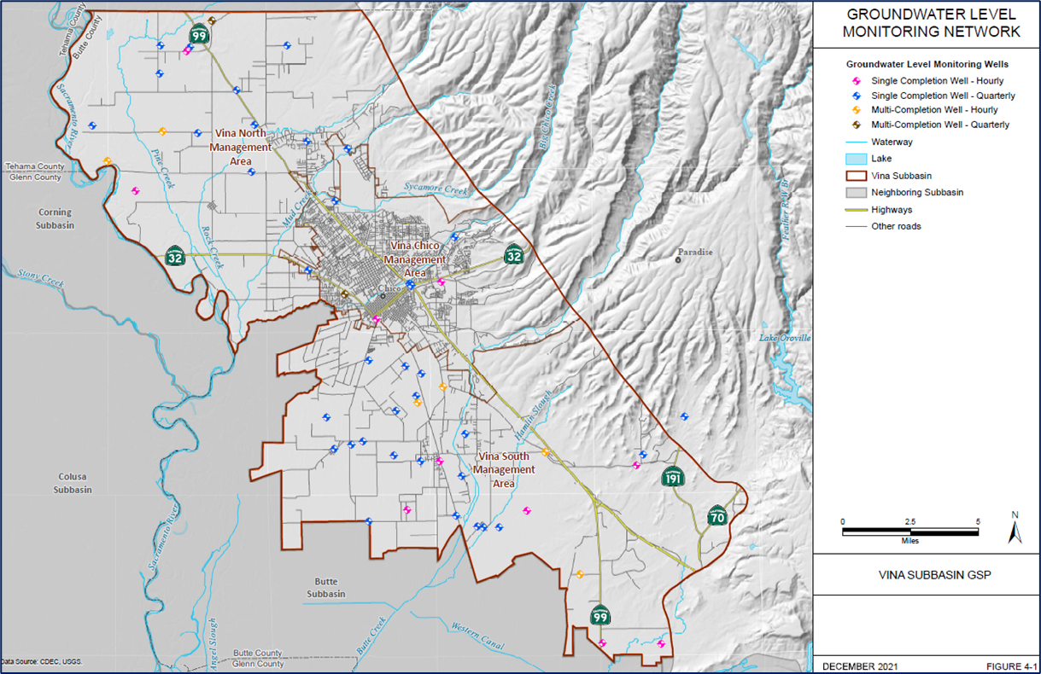
Figure 1. Map of existing groundwater level monitoring network (Vina Groundwater Subbasin GSP, Figure 4-1, page 165).
2.1. Monitoring Network Enhancements
To refine the site selection process for new wells and stream gages in the groundwater monitoring network, LWA in coordination with GSA staff have established the following site selection criteria:
- Data Gaps – Prioritize locations that will help address data gaps identified in the GSP and DWR’s Determination Letter which includes ISWs and GDEs. The Butte Basin Groundwater Model was used to identify potential ISWs. Potential GDEs were identified using the Natural Communities Commonly Associated with Groundwater dataset developed by DWR, the California Department of Fish and Wildlife (CDFW), and The Nature Conservancy (TNC).
- Land Access – The GSA will locate new sites along County and City easements when feasible or establish landowner agreements as needed.
- Existing Infrastructure – Prioritize utilizing existing infrastructure to avoid unnecessary drilling and well construction expenses, when possible. For stream gages, locating and reactivating inactive sites will generally be more cost-effective than establishing new gaging sites.
- SGMA Projects – Prioritize sites that could benefit other SGMA projects. For example, the Lindo Channel Recharge Project will require shallow wells to help quantify recharge. Installing both shallow wells in the area could help analyze benefits provided by such a project in the short term, while also serving as long-term monitoring sites for ISWs/GDEs.
- Water Quality – To the extent possible, new wells will support subbasin groundwater quality monitoring efforts and fill gaps in the water quality monitoring network.
- Priority Watersheds – While most wells and stream gages will be placed in accordance with the criteria listed above, the GSA may have the opportunity to install additional stream gages under the Stream Gage Improvement Program (CalSIP) in “Priority Watersheds” as described in the 2022 California Stream Gaging Prioritization Plan. The CalSIP Priority Watersheds in Vina Subbasin include Singer Creek, Pine Creek, Rock Creek, Commanche Creek, Hamlin Slough, and Dry Creek.

2.2. Domestic Well Survey
A desktop survey was performed to locate parcels with domestic wells using the County Assessor’s Office parcel use codes. The goal of this survey was to refine the GSA’s existing domestic well dataset and to identify areas with a high density of domestic wells at risk of going dry (deemed “Priority Areas”). In the desktop survey, parcels within Cal Water and Durham Irrigation District service areas were excluded from the analysis due to being served by a public water supply system. Parcels zoned for agriculture were only included if they had a building with a known address.
The GSA will hold outreach events to solicit interest from community members in Priority Areas in preparation for the launch of the Community Monitoring Program to monitor domestic wells throughout the Subbasin.

3. RESULTS

3.1. Monitoring Network Enhancements
A map of the proposed monitoring network for the Vina Subbasin is shown in Figure 2. Of the seventy-eight (78) existing wells included in the groundwater level monitoring network (see GSP Section 4.2), Dr. Todd Greene’s analysis identified thirteen (13) as shallow. Shallow wells are screened in the upper and lower Quaternary deposits. These sites are summarized in Table 1 with hydrographs provided in Appendix A.
Table 1. Existing representative monitoring wells measuring groundwater levels in the upper aquifer. Continuous sites are equipped with sensors. Monthly sites are measured each month, if feasible, by DWR or Butte County.
SWN / Map Label | Monitoring Frequency | Well Type | Collecting Agency
23N01W09E001M (1) | Monthly | Irrigation | Butte County / DWR
23N01W28M005M (2) | Continuous / Monthly | Observation | Butte County / DWR
23N01W27L001M (3) | Monthly | Residential | Butte County / DWR
23N01W31M004M (4) | Continuous / Monthly | Observation | Butte County / DWR
22N01E20K001M (5) | Monthly | Residential | Butte County / DWR
21N01E27D001M (6) | Monthly | Residential | Butte County / DWR
21N01E28F001M (7) | Monthly | Irrigation | Butte County / DWR
21N01E25K001M (8) | Monthly | Residential | Butte County / DWR
21N02E32E001M (9) | Monthly | Irrigation | Butte County / DWR
23N01W14R002M (10) | Monthly | Irrigation | Butte County / DWR
23N01W36P001M (11) | Monthly | Residential | Butte County / DWR
22N01E09B001M (12) | Monthly | Residential | Butte County / DWR
22N02E30C002M (13) | Continuous / Monthly | Observation | Butte County / DWR

As illustrated on Figure 2, the long-term goal for the shallow monitoring network is to install wells near streams and potential GDEs in areas delineated with blue circles, indicating high priority locations, and orange squares, indicating lower priority locations. The high priority monitoring sites are located along Big Chico Creek, Butte Creek, Mud Creek, and Lindo Channel. shallow well will be installed at the nine (9) high priority locations under the SGM Grant pending review of other existing shallow monitoring wells in the area (e.g., City of Chico nitrate monitoring wells) that may be used instead of drilling a new well. Additional shallow wells will be installed in areas identified by the orange squares as funding allows.
A multi-completion well is proposed at site labeled M1 as illustrated on Figure 2. This location is not covered by an existing monitoring well, located along a section of Pine Creek that transitions from a gaining and losing stream according to the Butte Basin Groundwater Model, surrounded by agricultural pumping, and located to the west of an area with a significant number of domestic wells.
It is recommended to install three stream gages along Big Chico, Little Chico, and Butte Creeks with SGM grant funding. Additional stream gages along Pine, Rock, Camanche, and Dry Creeks and Hamlin Slough may be installed with CalSIP funding (see purple circles on Figure 2). A long-term goal is to measure near ISWs and GDEs and water entering and leaving the Subbasin through streams.

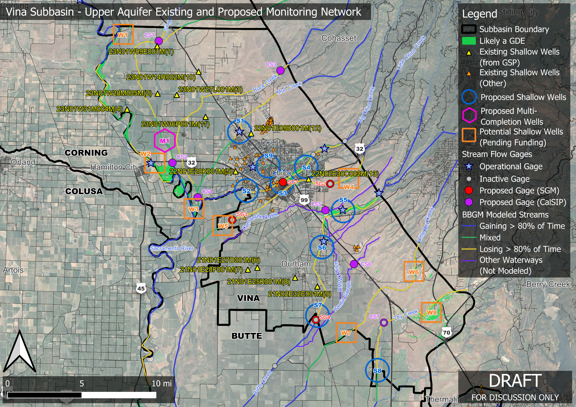
Figure 2. Map depicting existing, planned, and potential shallow monitoring wells within the Vina Subbasin.

3.3. Domestic Well Survey Preliminary Results
The domestic well survey based on parcel information identified 1,342 domestic wells within the Vina Subbasin. A map of the domestic well survey results with delineated Priority Areas are shown in Figure 3. For comparison, DWR estimates approximately 2,300 domestic wells within the Vina Subbasin based on the number of well completion reports (WCRs) received since 1977. The parcel-based approach may be a better representation of the actual number of wells in the Subbasin as some domestic wells have likely been replaced over time. Further coordination with Cal Water is recommended to identify parcels within their service area without service.
Approximately fourteen well owners have volunteered their domestic wells to be monitored under the Community Monitoring Program (see purple points on Figure 3). These wells will be further evaluated to assess the suitability to participate and be monitored through the Program. The GSA has funding to install monitoring equipment on eight domestic wells.

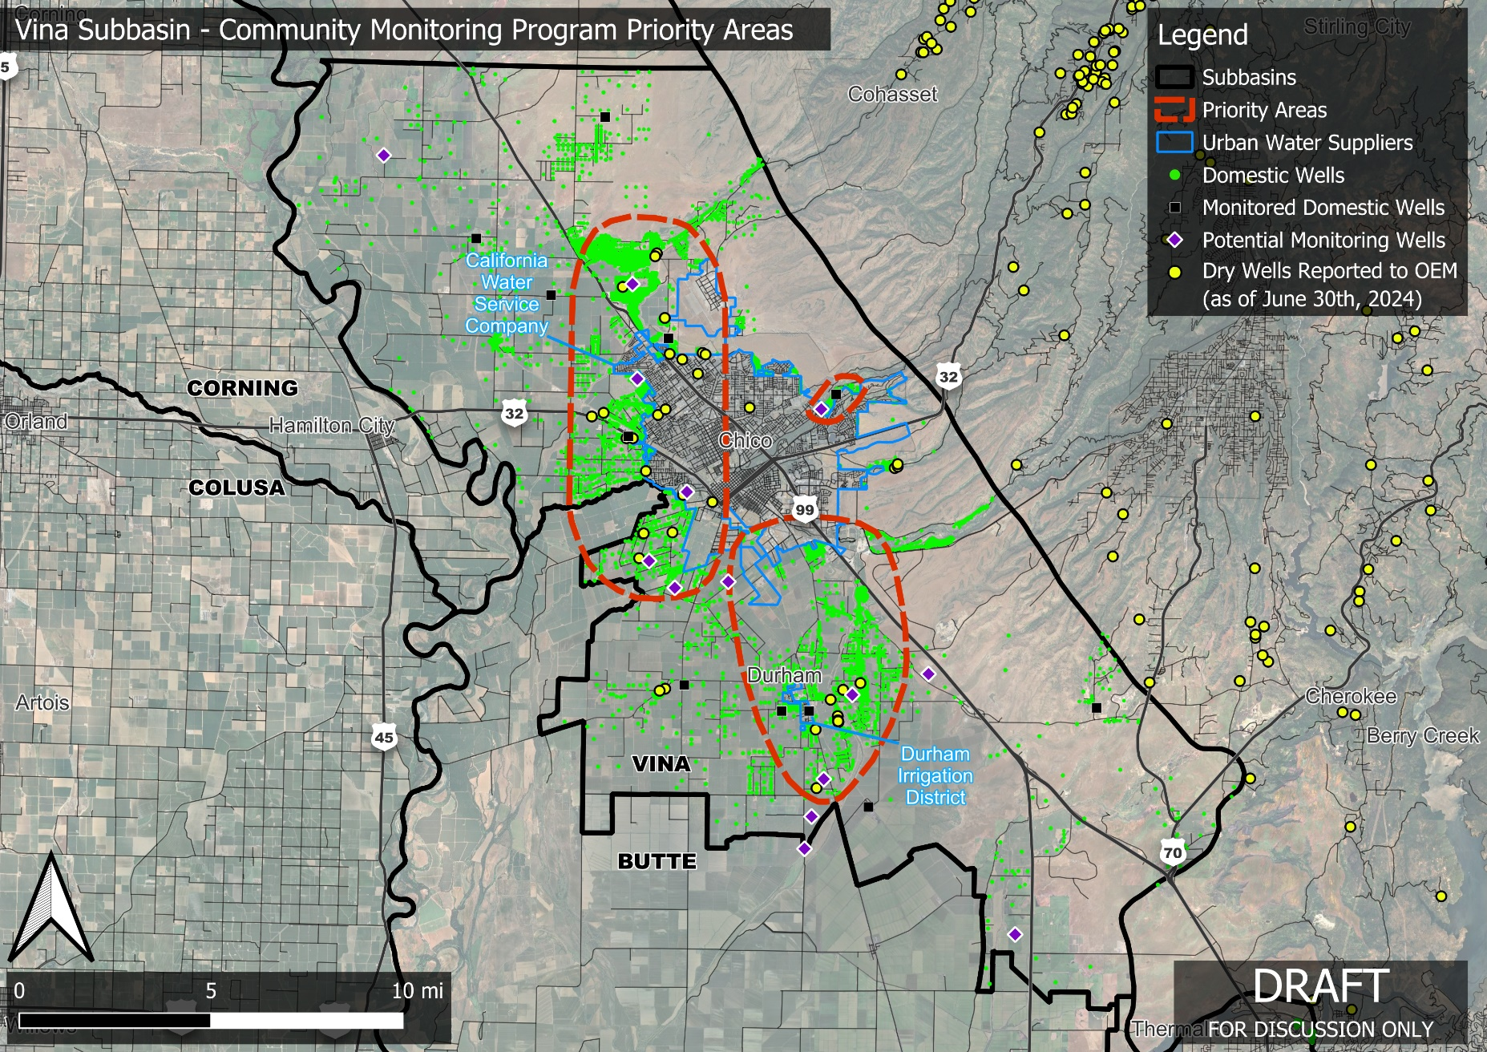
Figure 3. Map depicting results of the domestic well survey. Priority areas were delineated from the domestic well survey results and the dry wells reported to Butte County OEM through June 30, 2024.

4. NEXT STEPS
The LWA Team in coordination with GSA staff are actively soliciting input on the proposed enhanced monitoring network from local stakeholders. To date, we have engaged the following groups for input:
- Members of Butte County Technical Advisory Committee,
- Agricultural Groundwater Users of Butte County,
- Friends of Butte Creek,
- The Nature Conservancy, and
- Other GSA/County technical consultants.
The LWA Team will continue to request input from stakeholders over the next two months. The schedule to request input from the Vina GSA Stakeholder Advisory Committee (SHAC) and the Board of Directors is summarized in Table 2. Updates will be provided to the SHAC and Board of Directors at their October and November meetings, respectively. Final recommendation and approval from the SHAC and Board of Directors is tentatively scheduled for November 20, 2024, and December 11, 2024; respectively.
Table 2. Proposed SHAC and Board of Directors input process schedule.
Group | Meeting Date | Purpose
SHAC | October 23, 2024 | Monitoring Network Update
Board of Directors | November 13, 2024 | Monitoring Network Update
SHAC | November 20, 2024 | Recommendation to Board
Board of Directors | December 11, 2024 | Final Board Approval

The LWA Team in coordination with GSA staff will continue to advance activities to ensure installation of the monitoring network remains on schedule. Landowner access agreements (as applicable), final monitoring well designs and specifications, and bid documents will be completed by January 2025. Well contractors will be given notice to proceed by February 2025 with all new wells installed by June 2025. Stream gage installations will start in December 2024 once final approval is granted by the Vina GSA Board of Directors.
Table 3 summarizes installation and annual operating and maintenance (O&M) costs for groundwater level monitoring sites and stream gages. Installation costs will be covered by the grant. The GSA will be responsible for funding ongoing O & M of monitoring sites. Costs assume sites will be equipped with telemetry to automatically view data online in near real-time via an online stakeholder portal. Monitoring equipment will be installed once wells are drilled, and domestic wells and stream gage locations are selected for monitoring.
Table 3. Installation and O&M costs for groundwater level monitoring sites and stream gages.
Site Type | Installation Costs ($/site) | Annual O&M Cost ($/site)
Groundwater Level¹ | $6,500 - $11,000 | $1,000 - $2,500
Stream Gage² | Up to $35,000 | $4,000 to $8,000
Notes:
- Costs vary based on the following factors: type of sensor (e.g., sonar vs submersible), number of well completions, well casing diameter, and depth to groundwater.
- Costs vary based on site flow conditions and ease of access. Assumes a minimum of three stream measurements at low, medium, and high flow are conducted to develop stage – discharge curve and at least one measurement is taken every year to validate stage-discharge curve.

APPENDIX A

Vina Subbasin Groundwater Hydrographs for Existing Shallow Wells

(Identified Through Dr. Todd Greene’s Analysis)

Vina GSP and Determination Letter available here: https://sgma.water.ca.gov/portal/gsp/preview/86
Plan available here: https://www.waterboards.ca.gov/waterrights/water_issues/programs/stream_gaging_plan/
California’s Groundwater Live website link: https://sgma.water.ca.gov/CalGWLive/#wells

